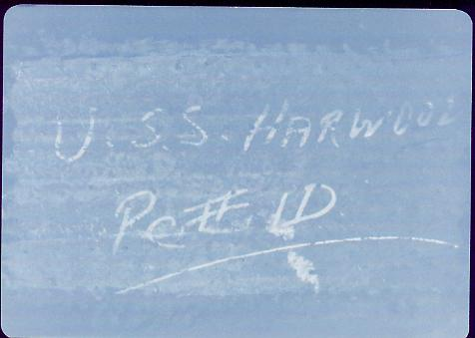

The USS HARWOOD (DD/DDE 861) is still alive!!!!!!

The above picture was taken in 1979 at Fall River, Massachusetts. Maurice Crotteau, on board from 1947 to 1952 was doing some volunteer work in the USS Joseph P. Kennedy (DD 850), where they were chipping the after stack to do some repainting. The volunteer that was doing the work brought the above inscription to Maurice’s attention. As near as can be figured, the KENNEDY and the HARWOOD were in the Brooklyn Navy Shipyard together for FRAM and the yard had apparently removed both stacks for work. When they were put back on the switch was made. No one knows why but if you do please let us know so we can clear up the mystery.

